HashCash algorithms use a service string, a nonce and a counter as parameters.

Bitcoin Hashcash UPDATED:
The bitcoin hashcash algorithm uses information from the block header. There are 6 fields in the block header these are:
-Version (4 Bytes)
-hashPrevBlock (32 Byte – 256-bit hash of the previous block header)
-hashMerkleRoot (32 Byte – 256-bit merkle root hash)
-Time (4 Byte current timestamp in Unix Time)
-Bits (4 Byte difficulty)
-Nonce (4 Byte number starting at 0)
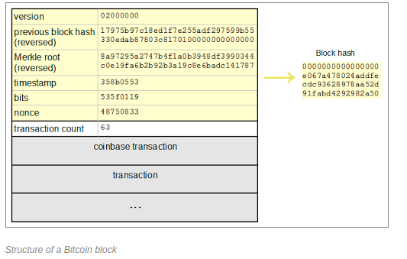
Source: http://www.righto.com/2014/02/bitcoin-mining-hard-way-algorithms.html#ref3
when the Nonce overflows, the exraNonce value is incremented by one. The extraNonce value exists in the coinbase transaction, so that when it is incremented, the merkle hash is changed

The header hash is a hash of these 6 fields all in hex notation, concatenated together (in the order listed above) as little-endian. In the photo above all the fields are in little-endian. e.g Verson number is 2 yet the switching of least significant bits to lower memory address makes the Verson Number appear 02000000. This is known as little endian. The block header is a concatination of all these fields in little-endian (which they are currenlty in as shown above) in descending order as shown above before hashing. Before hashing, the concatinated block header is converted from hex to binary, hashed and hash again. The final hash can then be converted to big endian to be viewed. So when you hash make sure its in binary(uinless the hash automatically converts the hex to binary) .
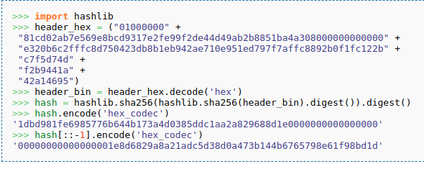
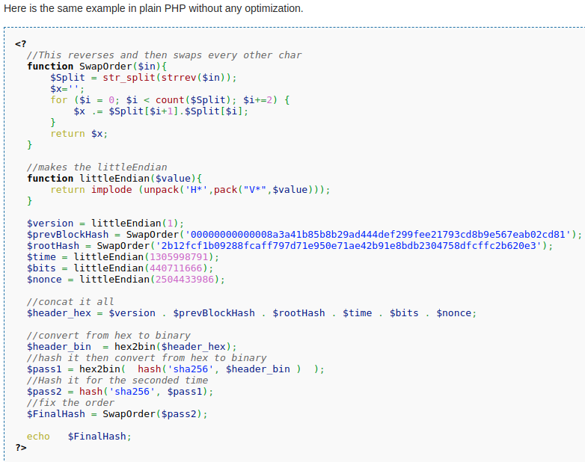
Source: https://en.bitcoin.it/wiki/Block_hashing_algorithm

-Note on block explorer the previous block hash is displayed in big-endian e.g. 0’s are at the beginning.
Bitcoin hashes this block header twice: SHA256(SHA256(header)), and you need to be careful about bite order (little endianess).

Source: https://classes.engineering.wustl.edu/ese461/FinalProject/Bitcoin/BitcoinDescription.pdf
Source: https://en.bitcoin.it/wiki/Difficulty
Source: http://www.righto.com/2014/02/bitcoin-mining-hard-way-algorithms.html#ref3
SHA256 files used in my hashCash C implementation:
https://github.com/B-Con/crypto-algorithms/find/master

My C code example of hashing of a block, specifically block #125552 this example is based off the python example above (as it uses the same block). This uses a C SHA256 hashing function from the following source: https://github.com/B-Con/crypto-algorithms/find/master specifically the files sha256.c and sha256.h are needed, a useful reference for using the SHA256 function was found in the test file sha256_test.c
This was a test example before moving on to implementing a hashcash algorithm.
Compiled with command: gcc -Wall -Werror sha256.c basicHashCash.c -o test

//My C code implementaion of the hashing of BLOCK #125552 using a SHA256 hashing
//SHA256 function from https://github.com/B-Con/crypto-algorithms/find/master

#include <stdio.h>
#include <memory.h>
#include <string.h>
#include "sha256.h"

void printSHA256(BYTE *buf){
for(int x = 0; x < SHA256_BLOCK_SIZE; x++){
unsigned char mask1 = 0xf0; //create bit mask 11110000
unsigned char mask2 = 0x0f; //create bit mask 00001111

mask1 = mask1 & buf[x];
mask1 = mask1 >> 4;

mask2 = mask2 & buf[x];
printf("%x%x", (unsigned int)mask1, (unsigned int)mask2);
}
printf("\n");
}

int main(){
/*this unsigned char array contains the Verson + previous block hash + merkle root hash
+ time + difficulty + nonce.
each hex field was converted to little-endian before concatination.
example is from source: https://classes.engineering.wustl.edu/ese461/FinalProject/Bitcoin/BitcoinDescription.pdf
*/
BYTE text1[] = {0x01, 0x00, 0x00, 0x00, 0x81, 0xcd, 0x02, 0xab, 0x7e, 0x56, 0x9e,
0x8b, 0xcd, 0x93, 0x17, 0xe2, 0xfe, 0x99, 0xf2, 0xde, 0x44, 0xd4, 0x9a, 0xb2,
0xb8, 0x85, 0x1b, 0xa4, 0xa3, 0x08, 0x00, 0x00, 0x00, 0x00, 0x00, 0x00, 0xe3,
0x20, 0xb6, 0xc2, 0xff, 0xfc, 0x8d, 0x75, 0x04, 0x23, 0xdb, 0x8b, 0x1e, 0xb9,
0x42, 0xae, 0x71, 0x0e, 0x95, 0x1e, 0xd7, 0x97, 0xf7, 0xaf, 0xfc, 0x88, 0x92,
0xb0, 0xf1, 0xfc, 0x12, 0x2b, 0xc7, 0xf5, 0xd7, 0x4d, 0xf2, 0xb9, 0x44, 0x1a,
0x42, 0xa1, 0x46, 0x95};
//below is text0 which is the string of the header fields, this is not in hex so it would not work
//the hashing needs to be in bits, hex values in unsigned chars is interpreted as bits but chars
//such as in text0 as a string is a interpreted differently then text1 and is therefore incorrect in
//producing bitcoin block hashes.
/* BYTE text0[] = {"0100000081cd02ab7e569e8bcd9317e2fe99f2de44d49ab2b8851ba4a
308000000000000e320b6c2fffc8d750423db8b1eb942ae710e951ed797f7affc8892b0f1fc12
2bc7f5d74df2b9441a42a14695"};
*/
BYTE buf[SHA256_BLOCK_SIZE];
BYTE buf2[SHA256_BLOCK_SIZE];
SHA256_CTX ctx;

//calculates first hash
sha256_init(&ctx); //initialize hashing function
sha256_update(&ctx, text1, 80); //80 represents the size in bytes of the block header
sha256_final(&ctx, buf);

//print current hash
printSHA256(buf);

//second hash using first hash
sha256_init(&ctx);
sha256_update(&ctx, buf, 32);//32 is the hash byte size of the first block header hash
sha256_final(&ctx, buf2);

//print final hash
printSHA256(buf2);//the final hash is in little endian.

return 0;
}

Results:
This program printed the following hashes in hex:
b9d751533593ac10cdfb7b8e03cad8babc67d8eaeac0a3699b82857dacac9390
1dbd981fe6985776b644b173a4d0385ddc1aa2a829688d1e0000000000000000

the first hash was the first of the two hashes while the second is the final and represents the block header for block #125552 as shown in the block explorer: https://blockexplorer.com/block/00000000000000001e8d6829a8a21adc5d38d0a473b144b6765798e61f98bd1d

Difficulty:
Before continuing with creating the hashcash function, it is necessary to understand how the difficulty works and how it is represented in a 4 byte hex number.
-Difficulty is the measure of how hard it is to find a valid hash below a target.
Difficulty is calculated by taking the highest possible target and dividing it by the current target.
Difficulty = Highest_target/Current_target; where target is a 256 bit number
In bitcoin, the difficulty is stored as a packed 4 byte representation of its hexidecimal target known as “Bits”.
Hexidecimal target is derived by
0xXXXXXX*2^(8*(0xZZ – 3)) = 0x……..
where 0xZZXXXXXX is the packed representation of the hexidecimal target where the 0xZZ is the hexidecimal value of the first two values in the packed target and 0xXXXXXX is the last 6 values of the packed target.
e.g packed target = 0x1b0404cb
hexidecimal target:
0x0404cb * 2**(8*(0x1b - 3)) = 0x00000000000404CB000000000000000000000000000000000000000000000000

Bitcoin’s hashcash algorithm uses the packed target to calculate the hexidecimal target so that it can then compare the block header hash and the hexidecinal target and see if the hash complies with the difficulty level.
Source: https://en.bitcoin.it/wiki/Difficulty

The highest target is 0x00000000FFFFFFFFFFFFFFFFFFFFFFFFFFFFFFFFFFFFFFFFFFFFFFFFFFFFFFFF
since bitcoin stores this as a floating point number the higest target is lowered to 0x00000000FFFF0000000000000000000000000000000000000000000000000000
The highest target above is actually the lowest difficulty. This is because the more 0’s beginning from the 0x the harder it is to find a hash with MORE zero’s in the beginning of the hash (I.e it is less likely given hashing is random) therefore a hash with one zero at the beginning: 0x0F is less difficult then finding a hash with 2 zeros at the beginning: 0x00F.
-highest target = lowest difficulty
Source: https://en.bitcoin.it/wiki/Target

e.g on difficulty:

0x00000000FFFF0000000000000000000000000000000000000000000000000000 /
0x00000000000404CB000000000000000000000000000000000000000000000000
= 3FB3.6BC2A08A2 = 16307.420938524 in decimal, in words this difficulty number represents how many times longer it would take to find a correct hash compared to the easiest difficulty (highest target). Source: https://bitcoin.stackexchange.com/questions/8806/what-is-difficulty-and-how-it-relates-to-target

